|  |  |  |  |  |  |  |
| --- | --- | --- | --- | --- | --- | --- |
| PROD Environment : OLSS Web Server IP : 192.168.140.21 OLSS Database Server IP: 192.168.140.26 OLSS Job File Server IP :DRC Environment : OLSS Web Server IP : 172.24.1.42 OLSS Database Server IP: 172.24.3.28 OLSS Job File Server IP : | | | | DSF Project Name : **Operating Lease Support System**  Name : Fajar  Department : BSI  Date : 16 September 2019 | | |
| |  |  |  |  | | --- | --- | --- | --- | | **Release Form** | **UAT Reference** | Classification Critical  High  Medium  Low | Category New Request  Enhancement Major  Enhancement Minor  Correction | | No. : 16092019-01  Date : 16 September 2019  Ticket No : **S0171480**  Change No : **C0023838** | 1. UAT Environment: http://10.1.1.37/olss_crS0171480/Account/Login  2. UAT Date : 13 September 2019  3. PIC : Fahmi Afandi | | | | | | | |
| **Subject: Add New Column for Supplier Address in Maintenance Payment Approval & Supplier Information** | | | | | | |
| **Description of Change**  Show Supplier Address in menu Maintenance Payment Approval & Supplier Information.  **Root cause:**  Supplier Address is not available both on screen and document printing.  **Fixing:**   1. Add new column of Supplier Address in menu Maintenance Payment Approval & Supplier Information. 2. Add new field of Address in print-out document of Payment Approval Maintenance.   **BEFORE:**   1. Supplier Addres is not available in menu Maintenance Payment Approval and print-out document. 2. Supplier Addres is not available in menu Supplier Information.   **AFTER:**   1. Supplier Addres is available in menu Maintenance Payment Approval and print-out document. 2. Supplier Addres is available in menu Supplier Information. | | | **Release Scenario to Production:**   |  |  |  |  | | --- | --- | --- | --- | | **No.** | **Task** | **Duration** | **PIC** | | **1.** | Stop IIS in web server (192.168.140.21) | **5 minutes** | **Firmansyah** | | **2.** | Setting connection | **5 minutes** | **Firmansyah** | | **3.** | Deploy .net file | **15 minutes** | **Firmansyah** | | **4.** | Start IIS in web server (192.168.140.21) | **5 minutes** | **Firmansyah** |   **After Release to Production:**   |  |  |  |  | | --- | --- | --- | --- | | **No.** | **Task** | **Duration** | **PIC** | | **1.** | Login to OLSS Web Application and access Maintenance Payment Approval & Supplier Information. | **5 minutes** | **Neny** |   **Release Scenario to DRC:**   |  |  |  |  | | --- | --- | --- | --- | | **No.** | **Task** | **Duration** | **PIC** | | **1.** | Stop IIS in web server (172.24.1.42) | **5 minutes** | **Aryo Budi** | | **2.** | Setting connection | **5 minutes** | **Aryo Budi** | | **3.** | Deploy .net file | **15 minutes** | **Aryo Budi** | | **4.** | Start IIS in web server (172.24.1.42) | **5 minutes** | **Aryo Budi** |   **After Release to DRC:**   |  |  |  |  | | --- | --- | --- | --- | | **No.** | **Task** | **Duration** | **PIC** | | **1.** | Login to OLSS Web Application and access Maintenance Payment Approval & Supplier Information. | **5 minutes** | **Neny** | | | | |
| **Consequence if not done:**  Users can choose wrong supplier because there’s no information of supplier address. | | | **Rollback Plan**  *(If the release activity fail)*  Replace the files from backup folder in SVN with URL:  [https://172.17.25.33/svn/OPR/DSF/OLS Operation/Documents/Change Request/CR2019_XXX S0171480 C0023838 - Add New Column for Supplier Address in Maintenance Payment Approval & Supplier Information](https://172.17.25.33/svn/OPR/DSF/OLS%20Operation/Documents/Change%20Request/CR2019_XXX%20S0171480%20C0023838%20-%20Add%20New%20Column%20for%20Supplier%20Address%20in%20Maintenance%20Payment%20Approval%20&%20Supplier%20Information) folder. | | | |
| **File Name & SQL Script to Release:**  **Dot Net File:**   * **Dsf.Olss.dll** * **Dsf.Olss.Service.dll** * **Dsf.Olss\Reports\MaintenancePaymentApproval.rdlc** * **Dsf.Olss\View\MaintenancePaymentApproval\Add.cshtml** * **Dsf.Olss\View\MaintenancePaymentApproval\ModalPopUp.cshtml** * **Dsf.Olss\View\Supplier\Index.cshtml** | | | **Release Plan**  **Date: 16 September 2019**  **Time: 17:00** | | | **Release Actual**  **Date:**  **Time:** |
| **Before Release** | | | | | **After Release** | |
| Requested by | Approved by | Approved by | | | Checked by Requester | Checked by Superior |
| Date: __ ___ ____ | Date: __ ___ ____ | Date: __ ___ ____ | | | Date: __ ___ ____ | Date: __ ___ ____ |
|  |  |  | | |  |  |
| Fajar | Devilosa Indra Kamal | Valentinus A. Bay Meo | | | Fajar | Devilosa Indra Kamal |

**ATTACHMENT**

**BEFORE**

1. **Screen Supplier Information**

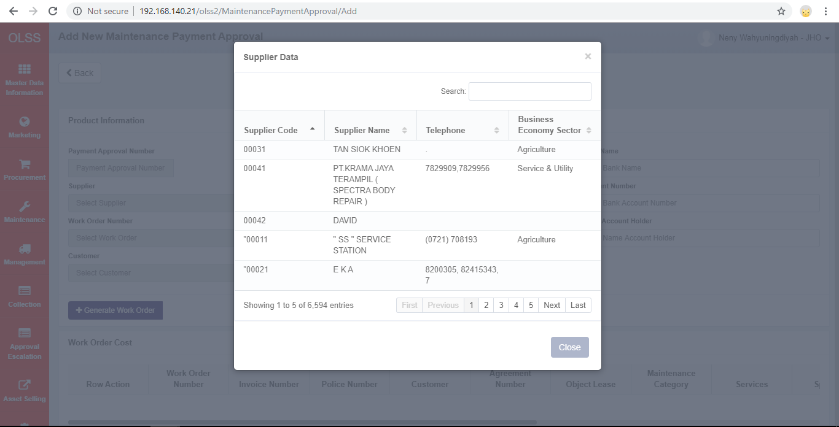

1. **Screen Maintenance Payment Approval**



1. **Print-out Document Maintenance Payment Approval**

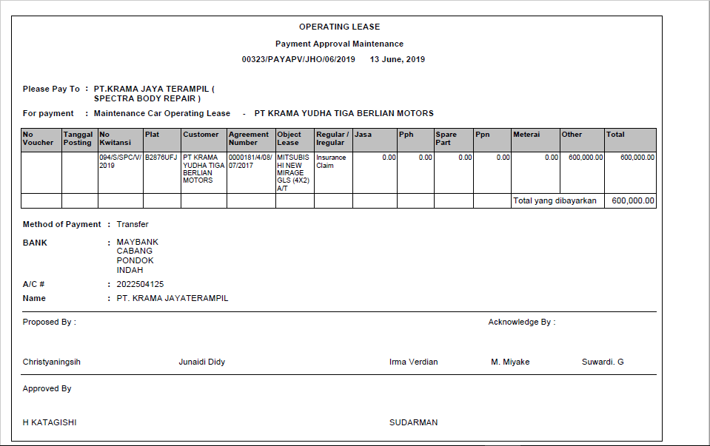

**ATTACHMENT**

**AFTER**

1. **Screen Supplier Information**

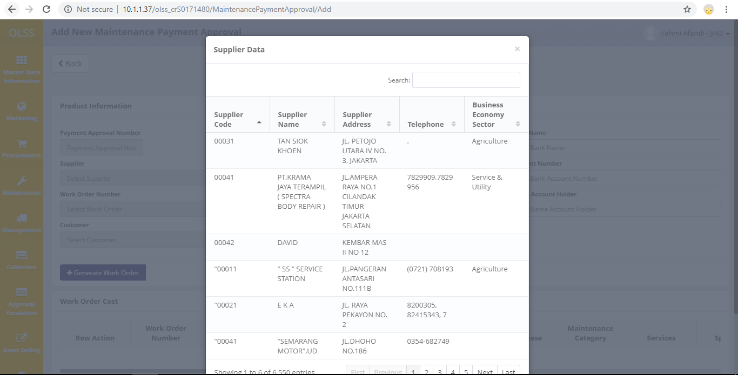

1. **Screen Maintenance Payment Approval**



1. **Print-out Document Maintenance Payment Approval**

